



# Incident Response Platform Integrations

# Machine Learning Function V1.0.0

Release Date: December 2018

Resilient Functions simplify development of integrations by wrapping each activity into an individual workflow component. These components can be easily installed, then used and combined in Resilient workflows. The Resilient platform sends data to the function component that performs an activity then returns the results to the workflow. The results can be acted upon by scripts, rules, and workflow decision points to dynamically orchestrate the security incident response activities.

This is a reference guide for the Resilient Machine Learning Function.

Overview

Machine learning can extract knowledge from historical incidents stored in a Resilient platform. This knowledge normally includes useful pattern information of the customer environment. More importantly, it can even include the experience of security analysts who have worked on those historical incidents. In some sense, a machine learning model learns from the previous decisions the security analysts made. Thus, machine learning can be very useful in assisting security analysts to make quick and proper response.

The following graph shows possible applications of machine learning in an incident response system like Resilient. Please note that current release supports classification only. Regression and other potential applications are not supported yet.

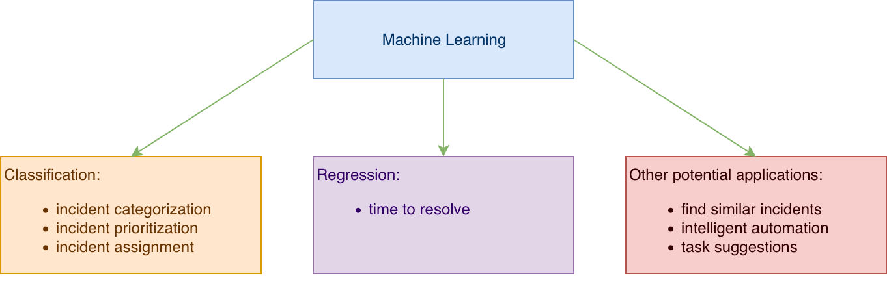

Resilient Machine Learning Function is highly customized for incident response system. It is also fully integrated to the Resilient Platform to provide best user experience, and can be incorporated into a custom workflows in flexible ways. In addition, user data is processed locally, customers thus do not need to concern about transmitting sensitive data to the cloud when a machine learning model is built.

This guide includes background information about features supported by the Resilient Machine Learning Function. In addition, it also includes recommendations to resolve common issues Resilient platform users might face.

Architecture

The Resilient Machine Learning Function contains two components.

* A command line tool to build a machine model
* A function component to predict using a machine model

A screenshot of a cell phone


This guide focuses on the command line tool that builds machine learning models. It will be referred as “the res-ml tool” in this guide for simplicity.

Dependencies

The is a python based application. It depends on the following third party python packages for machine learning support:

* [Scikit-learn](https://scikit-learn.org/) 0.19.2: An open source python package for machine learning with BSD license. It is built on Numpy and SciPy. The uses the machine learning algorithms supported by scikit-learn.
* [Pandas](https://pandas.pydata.org/) 0.23.3: An open source python package for easy-to-use data structures and related analysis tools. It also has a BSD license. The uses pandas to manipulate datasets, which are collection of incidents. This includes extracting features from incidents, filtering samples, and up-sampling training dataset.
* [Numpy](http://www.numpy.org/) 1.12.1: A fundamental package for scientific computing with Python with BSD license.
* [Scipy](https://www.scipy.org/) 1.1.0: An open source python package for mathematics, science, and engineering with BSD license.

Workflow of Machine Learning

To use the to build a machine learning model, it follows the general workflow of machine learning as shown below.

A screenshot of a cell phone


There are three steps. The first step is to preprocess the raw data and get it into shape. Filters can be used in this to remove dirty data. In addition, some raw data needs to be scaled and transformed for optimal performance of machine learning algorithms. The raw data here is the collection of historical incidents. The output of this step is the samples to be used in building a machine model. There samples are sometimes referred as dataset.

The second step is to build a machine learning model. In this step, users need to pick which incident field they want a machine model to predict. This will be referred as the prediction field hereafter. They also need to pick incident fields that are relevant to the prediction fields. Those fields will be the features for the machine learning model. Simply put, the features are the inputs for the machine learning model, and the prediction field is the output from the machine learning model. Therefore, the quality of the input data is critical for building a successful machine learning model. One can even say that the quality of the input data determines the upper limit of the performance of a machine learning model can possibly reach.

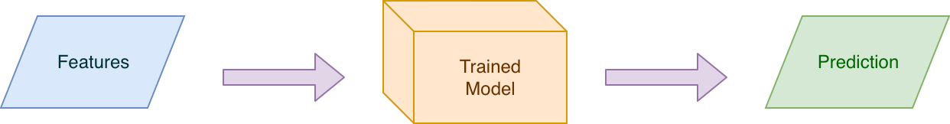

Also in this step, the users need to pick an algorithm for the machine learning model. The samples generated from the first step is then split into two subsets. One is used for training the model using the selected algorithm. The other is used to test the trained model. The performance of the trained model is measured during the test. Note that if the performance is not satisfactory, users can go back to the beginning and make adjustments in the first two steps, so as to fine-tune the model. They can repeat this until a good model is built.

The third step is to make prediction using the model built in the second step. New data is fed into the model to generate prediction. Note that after the machine learning model has been trained and tested, this can be done repeatedly and very rapidly.

For Resilient Machine Learning Function, the handles the first two steps, and the function component handles the last step. A machine learning model built by the is saved into a file. The function component reads the model from a file, and then make prediction using it.

Note that python package [pickle](https://docs.python.org/3/library/pickle.html) is used to serialize and deserialize a machine learning model. If users want to build a model from one machine and then use it from another machine, they need to make sure that the same version of python and pickle are installed into both machines.

Overview of the

The follows the general workflow given above.

A screenshot of a computer


The above is a data/control flow diagram that provides an overview about how the raw data is built into a machine model, and how users can control the building process by modifying settings in the app.config file.

Please refer to the following subsections for more details of each process shown in this flow diagram.

Preprocess Raw Data

This is about getting raw data in shape, and it is a critical step in machine learning. The applies the following techniques automatically because they are commonly recognized as the best practices.

Remove samples with blank values

When an incident is created, it is quite possible that sometimes one or more fields are left blank. A field with missing value can cause difficulties for a machine learning model if this field is selected as a feature or the prediction field. For example, users can select “confirmed” as a feature to predict “severity”. If “confirmed” was left blank when an incident was created, then this incident can confuse a machine learning model. It needs to be fixed before the dataset is used.

There are two commonly used solutions for this problem. First, if users know how to fill in the missing values, they can do it in this step. The advantage of this solution is that it preserves the total count of samples. But the disadvantage is that it is not an easy approach. Note that the dataflow of the Resilient Machine Learning Function is shown below. The incidents are first downloaded and saved into a CSV file, before they are used to build a machine model. This gives users the flexibility to preprocess the data before it is used.



Therefore, after users run

res-ml download -o resilient_incidents.csv

they can edit the CSV file and fill in the missing values if they want.

The other approach is to remove the samples with missing values if the corresponding fields are selected as features. The automatically remove those samples in the build process before data is fed to a machine learning algorithm. In other words, if advanced users want to do custom data preprocessing, they need to do it using the CSV file *before* the build command is used.

*For advanced user*, there is a useful command from the call count_value. It can show the sample count for each value of a given field. The users can use it to check a field before it is used as one of the features or the prediction field.

Example

res-ml count_value -i resilient_incidents.csv -f false_positive

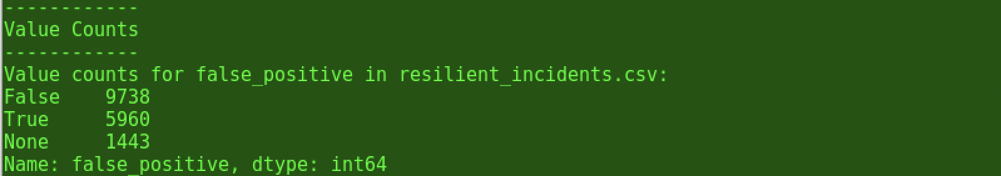

In this example, the value count of a custom field called “false_positive” is shown. There are 9738 samples for value “False” here. Note that value “None” represents missing value. The pandas package used in the automatically convert a blank value into “None”. Here we can see that there are 1443 samples with blank values.

Feature scaling

For most machine learning algorithms, to get the optimal performance, the numerical features need to be brought to the same scale. Otherwise the algorithms would pay most attention to the feature with bigger scale and ignoring the others.

The performs feature scaling automatically. The following two approaches are used depending on algorithm selected. Please refer to the following subsection for details about the algorithms and the approaches.

For advanced users, note that the approach cannot be customized yet at this point. There are hard coded in the .

|  |  |  |
| --- | --- | --- |
| Algorithm | LabelEncoder | Min-max scaling |
| Logistic Regression | Yes |  |
| Decision Tree | Yes |  |
| Random Forest | Yes |  |
| SVM |  | Yes |
| Gaussian Naïve Bayes | Yes |  |
| Bernoulli Naïve Bayes | Yes |  |
| K-Nearest Neighbor | Yes |  |

LabelEncoder

The scikit-learn [LabelEncoder](https://scikit-learn.org/stable/modules/generated/sklearn.preprocessing.LabelEncoder.html) is used to scale numerical features for some algorithms, as shown in the above table. The value of a feature will be encoded between 0 and number_of_values-1. For example, assume that a feature has the following values

[1, 2, 10, 100, 1000]

It is encoded into

[0, 1, 2, 3, 4]

Note that the maximum value after being encoded is 4, which is the count of distinct values minus 1.

Min-max scaling

The other approach to normalize a numerical feature is to do a special case of min-max scaling. It uses the following equation to encode value a value x:

Encoding categorical features

For many algorithms implemented in scikit-learn, categorical features (for example, SELECT fields in Resilient) need to be encoded as integer values. Here the scikit-learn LabelEncoder is used to perform the encoding.

Filters

Filters can be used to exclude the dirty data. The supports two kinds of filter at this point.

Time filter

Incident samples can be filtered by setting start time and end time. As we mentioned above, the quality of the data determines the best possible performance any machine learning model can reach. To get high quality data, the users of the Resilient Platform need to follow formal procedures and fill in values for necessary fields accurately. If the users know that the quality of data is good in certain time frame, they can use this time filter to include incidents only created within that time frame.

To set a time filter, edit the app.config and enter values for time_start and/or time_end. The format is “YYYY-mm-dd”.

Example

time_start=2018-10-01

time_end=2018-10-08

This time filter includes incidents created between 2018-10-01 and 2018-10-08 only in training and testing a machine learning model.

Samples of unwanted value of the prediction field

This filter is specific for prediction field.

Some values of the prediction field can cause confusion to a machine learning model. For example, some Resilient platform users create a “Unknown” selection for the incident field “severity”. This could be true when an incident is created, but eventually before the incident is closed, a more accurate value shall be selected and stored. If a user forgot to update this field, then the corresponding incident can cause confusion when a machine model is trained using this data to predict “severity”.

Also just like features with missing values, prediction field will missing value shall be excluded as well.

To exclude samples with a unwanted value, the users can edit app.config and enter this value into the list of unwanted_values.

Example

unwanted_value=None, 1234

Note the uses a python package called pandas to manipulate samples. Pandas treats an empty value as None. As a result, the following means excluding samples with blank value for the prediction field.

unwanted_value=None

If users don’t want to use this setting, they shall remove it or comment it out.

Max sample counts

The builds a machine learning model locally. Depending on the spec of the local machine, the build process could be lengthy. The users can control the maximum number of incidents to be used as samples to train an algorithm. However, please keep in mind that in general more incidents give a more accurate result. In addition, for most algorithms (except K-Nearest Neighbor), this only affects the performance of the process of building a model. Once a model is built, the performance of the prediction process is not affected by the number of incidents used to build the model.

This is done in the app.config by setting

max_count=10000

Splitting samples for training and testing

Once the samples are cleaned up and properly encoded, they are split into two subsets, one for training and one for testing. It is important to test a trained model with unseen samples.

The main reason for validating a machine model is that we need to know how well a model can predict real-world data in the future. This is called generalization performance of a model, because a model essentially generalizes what it learn from the historical data and applies the knowledge m to predict real-world data in the future.

The validation using the test data subset generates measurement that we can use to estimate the generalization performance.

Please refer to the “Test a machine learning model” subsection below for more details.

Users can change the setting of “split” in app.config:

split=0.5

Train a machine learning model

Select a prediction field

Prediction field can be selected from built-in or custom fields of an incident. For example, “severity” is one possible choice to predict.

This is done by editing the app.config file.

Example:

prediction=severity_code

Another possible choice for built-in field is the owner of an incident. A machine learning model can then look for possible pattern in the relation between certain types of incidents and the owner of them.

Select features

Note features can be selected from custom fields as well. Features can be set in the app.config file as a list of features separated by comma.

Example:

features=incident_type_ids, confirmed, negative_pr_likely

Select an algorithm

Generally speaking, each machine learning algorithm has its advantages and disadvantages. *For advanced users*, it is recommended that they should build several models using different algorithms, and then compare the performance.

Currently the following algorithms are supported:

* Logistic Regression
* Decision Tree
* Random Forest
* SVM
  + Linear kernel
  + Gaussian kernel
* Gaussian Naïve Bayes
* Bernoulli Naïve Bayes
* K-Nearest Neighbor

Please refer to the Appendix more information about these algorithms.

Users can select an algorithm by setting the algorithm field in the app.config file.

Example

algorithm=Logistic Regression

Note, use “SVM” for SVM with linear kernel, and “SVM with Gaussian kernel” for the other non-linear SVM.

Select ensemble methods (optional)

*This is for advanced users.* Ensemble methods are optional in building a machine learning model here. Also, ensemble methods discussed here only apply to classification models. Therefore a model is also referred as a classifier here.

An ensemble method combines multiple classifiers into an ensembled classifier. These classifiers can use the same or different algorithms in general. But at this point, the only supports individual classifiers using the same algorithm. The resulted ensembled classifier theoretically can provide better generalization performance than each individual classifier.

In general, multiple classifiers are trained using the whole or different portions of the same dataset. When these classifiers are used to predict, the same input is fitted to each individual classifier. Then the predictions from them are combined to generate the final prediction. One popular way to combine prediction is majority voting.

A screenshot of a cell phone


The supports two ensemble methods currently. Please refer to the Appendix for more information about these two methods.

* Bagging
* Adaptive Boosting

The users can select ensemble method by setting the method field in the app.config file.

Example:

method=Adaptive Boosting

Note, the does not apply ensemble method if the method field is commented out or if it is set to None.

Compensate imbalanced dataset

Imbalanced dataset is quite common for user data found in incident response systems. To get better performance, there are techniques to compensate an imbalanced dataset.

Imbalanced dataset

Imbalanced dataset is one that for a prediction field, one or more classes dominate. The under-presented class is normally called minority class, while the over-presented one is called majority class.

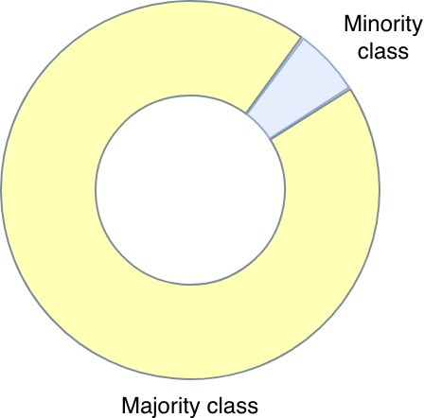

Imbalanced dataset may occur in data collected from spam filtering, fraud detection, or malware attack. Note that this depends on the prediction field being selected. Thus for the same dataset, it can be both balanced and imbalanced, depending on which field is selected as the prediction field. For example, the same set of incidents, it can be imbalanced when it is used to predict severity, while it is balanced when it is used to predict owner of an incident.

When imbalanced dataset is used to train a machine model, high overall accuracy can be easily achieved without the need to learn any useful knowledge from the dataset. For example, assume that data is collected from monitoring emails in order to detect spam. If the spam emails only represent 10% of the total data being collected, then this is a typical imbalanced dataset. The majority class represents normal emails, while the minority class represents spam emails here. To predict the future using machine learning, it is assumed that the future data has the same distribution as the historical data. Thus an overall accuracy as high as 90% can be easily achieved if a dummy model just predicts everything to be the majority class, meaning a normal email. This dummy model does not need to learn anything from the features. This dummy model is a special case of the Dummy Classifier discussed in the following subsection.

The overall accuracy of 90% seems high, but if we look at the accuracy for each value of the prediction field, the results are less satisfactory. The accuracy for the majority class is good, but this dummy model completely ignores the minority class.

|  |  |
| --- | --- |
|  | Accuracy |
| Overall | 90% |
| For normal | 100% |
| For spam | 0% |

This example shows that the overall accuracy is not the perfect measurement when handling imbalanced dataset, since model with high overall accuracy like this dummy model actually does not know how to predict a spam email.

A real machine learning model (without compensation) in general can improve the overall accuracy. The accuracy for the majority is most likely lower than 100%. The accuracy for minority class is most likely higher than 0%. However, most of the time, the accuracy for minority class is still pretty low if no compensation technique is used, as explained below using a binary classification.

Assume that a machine learning model is built for a binary classification. For simplicity, here we consider only two features, so that we can draw it in a 2D space. Each sample is represented by a dot, while the x-axis for feature1 and y-axis for feature2.

A picture containing sky, indoor, text, map


The above graph shows an ideal case in which a perfect solution exists. The red line can separate the red dots and blue dots completely. Note that the red line is the what the machine model learns from the data. Later on, when this model is used to make prediction, it just needs to figure out whether the new dot is above or below the red line. An ideal case shown here means 100% overall accuracy and 100% accuracies for both the red class and the blue class.

As we can imagine, in reality this does not happen so often. Most of the time, the overall accuracy cannot reach 100%. This means the machine learning model mis-classify some of the samples. When this happens, the model sometimes need to make decisions to choose different solutions. For example, in the following graph, the red line missed one red sample, while the green line misses two blue samples. The samples mis-classified result in accuracy smaller than 100%. In general, an algorithm tries its best to maximizes the overall accuracy, and thus the red line here is a preferable solution. This is the correct choice if the dataset is balanced.

A picture containing sky, text, indoor, map


If the dataset is imbalanced, then there is another factor we need to consider. Assume now that the blue class above is the minority class with only 50 samples, while the count of red samples is 1000. Missing two red dots only has a small negative impact on the accuracy of the red class (around 0.2%). But missing one blue dot lowers down the accuracy for blue class by 2%.

Now which line to choose depends on what the users care more about. If the users care more about the overall accuracy and the accuracy for the majority class, then the red line is the preferable one. Or say there is no need to compensate the model. If the users care more about the accuracy for the minority class, then the green line is better. This solution sacrifices the overall accuracy and the accuracy for the majority class a little, but it has a big improvement for the accuracy of the minority class. For our example here of monitoring emails, the accuracy for predicting spam email is more important than the accuracy of predicting a normal email. Thus it makes sense to compensate the model.

A machine learning algorithm without compensation for the imbalance dataset in general picks the red line to maximize the overall accuracy. There are techniques to compensate so that an algorithm will pick the green line instead.

Up-sampling

The first technique is called up-sampling. This technique makes multiple copies of each minority sample, and inserts these copies to the original dataset, so that the count of the minority class is the same as the majority class.

A screenshot of a cell phone


Now each minority sample dot now becomes multiple of them. As a result, a machine learning algorithm shall choose to mis-classify a single majority sample, rather than a group of minority samples.

One important note here. Up-sampling must be applied after the original dataset is split into the training set and the testing set. If we apply up-sampling first, then copies from the same original minority samples might be split into the training set and the testing set. This means a machine learning model is then trained and tested with the same sample. Also, up-sampling shall be applied to the training set only so that it does not affect the performance measurement obtained from the testing dataset.

To use up-sampling to compensate an imbalanced dataset, set the following in app.config

imbalance_upsampling=true

Balanced class_weight

Another useful technique is to set the class-weight of an algorithm. Some algorithms support setting weight to each class of the prediction field. The supports setting class_weight as “balanced”. It means a weight inversely proportional to the class frequencies in the input dataset. For example, if a minority class represents only 1/3 of the total samples, then its weight is 3 when class_weight is set to “balanced”. This setting essentially tells an machine learning algorithm that a single minority sample shall be considered as three. Thus it can achieve similar impact as the up-sampling technique.

Not all the algorithms supports class_weight. In general, one of these two technique is needed to compensate an imbalanced dataset.

|  |  |  |
| --- | --- | --- |
| Algorithm | Up-sampling | Class_weight |
| Logistic Regression | Yes | Yes |
| Decision Tree | Yes | Yes |
| Random Forest | Yes | Yes |
| SVM | Yes | Yes |
| SVM with Gaussian kernel | Yes | Yes |
| Gaussian Naïve Bayes | Yes | No |
| Bernoulli Naïve Bayes | Yes | No |
| K-Nearest Neighbors | Yes | No |

To use this technique, set class_weight in app.config

class_weight=balanced

Test a machine learning model

The prints out a summary of the performance once a model is built. The measurements shown in this summary are obtained by validating the trained model using the test dataset. The following measurements are shown:

* Overall accuracy
* Individual accuracy for each value of the predicted field
* F1-score

The following is an example of the summary of building a machine learning model. Besides information about how the model is configured, the measurements are shown at the end of the summary. The overall accuracy is 88.46%. F1-score is 0.8801. Accuracy for False class is 86.79% and the accuracy for True class is 91.17%.

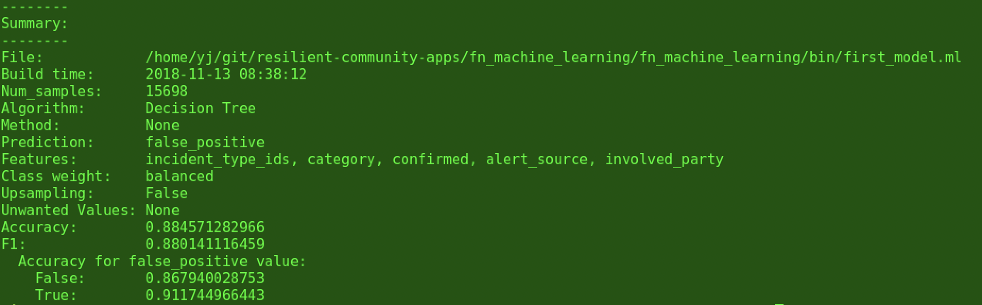

Overall accuracy

The overall accuracy is computed using the following equation:

The total accuracy given in the above screenshot is 88.46%.

Individual accuracy

The accuracy for each value is defined as the following

For example, the above screenshot shows two values: False and True.

The individual accuracy for False is 86.79%. The individual accuracy for True is 91.17%.

The individual accuracies are important when handling an imbalanced dataset.

F1-score

[F1-score](https://en.wikipedia.org/wiki/F1_score) can be used as a measure of a machine learning model. Here if the prediction field has only two possible value, it is then a binary classification. For this case, F1-score is defined as below:

As shown in its definition, F1-score is a weighted average of the precision and recall. Its minimum value is 0 and maximum is 1. In general, a higher F1-score means better performance of a machine learning model.

As for the multi-class case, F1 score is the average of the F1 score of each class.

The [scikit-learn.metrics.f1_score](https://scikit-learn.org/stable/modules/generated/sklearn.metrics.f1_score.html) function is used to compute the F1-score.

Dummy Classifier

*This for advanced users*. The scikit-learn package provides a test classifier called [Dummy Classifier](https://scikit-learn.org/stable/modules/generated/sklearn.dummy.DummyClassifier.html). It uses simple rules to make prediction. The purpose of this classifier is to generate a simple baseline that can be used as comparison in evaluating other real classifiers.

The dummy classifier included in the uses the “stratified” strategy. This means it makes prediction by respecting the training set’s class probability. For example, assume that the training set has two classes only: “True” and “False” for a customer field called “is_significant”, and the distribution is 70% vs 30%. The dummy classifier randomly make 70% “True” prediction and 30% “False” predictions.

Now assuming the testing data set has similar class distribution, the overall accuracy of this dummy classifier can theoretically computed as

A picture containing object


The reason is the following. As shown about, 70% of the testing set shall be the “True” class, as shown above as the blue arc, including the portion underneath the yellow arc. For these samples, the dummy classifier random 70% of them to be “True”, represented by the portion of the yellow arc that overlaps on top of the blur arc. So the true-positive rate is 70*70 here. Similarly, the true-negative is 30*30 here.

The accuracy of each class is the same as its probability

For “is_significant” as “True”, the F1-score can be computed as

For “significant” as “False”, the F1-score can be computed as

So the F1 score is

As shown in the above discussion, the dummy classifier does not use any of the features in its prediction. Or say it completely ignore any possible relation between the features and the prediction field. Therefore, it is only a test classifier, and shall not be used for any real prediction. It shall only be used for comparison.

Similarly, if a real machine model fails to gain any relation from the features and the prediction field, it shall have performance similar to the dummy classifier. This could happen if a user fails to pick any meaning features. For example, assume that a user picks incident id as the only feature to predict severity of an incident. Since there might not be any meaningful relation between the incident id and the severity of any incident, a machine model built like this would not be able to learn any useful knowledge from the data. As a result, the best the machine model can do in this case is to predict like the dummy classifier. Therefore, the dummy classifier sets the baseline for other real (useful) classifiers.

To get the base line using Dummy Classifier, set the algorithm field in the app.config file.

Example

algorithm=Dummy Classifier

In practice, the users can first set the algorithm to “Dummy Classifier” first, and build a model. Then they can change the algorithm to other real algorithm to build another real model. Comparing the performances from the above two model can show whether the real model is able to learn any useful knowledge from the data.

Troubleshooting

These are some possible errors users might encounter.

Single Class Error

This error happens when all the samples carry the same value for the prediction field. For example, if the prediction field is a custom field “urgency”, and all incidents have the same value, say “Low” as shown in the following table

|  |  |  |  |
| --- | --- | --- | --- |
| Incident_id | Customer | Urgency | Severity |
| 1001 | ABC | Low | High |
| 1002 | EFG | Low | High |
| 1003 | HIJ | Low | Medium |
| 1004 | KLM | Low | Medium |
| 1005 | XYZ | Low | Medium |
| 1006 | DEF | Low | Low |

If the users select Urgency as the prediction field, and set algorithm to Logistic Regression, then the output of the build command looks like this:



This means all the samples given in the above table has “Urgency” as “Low”. Basically a machine model does not need to do anything but just predict “Low’ all the time. Some algorithms like Decision Tree does just that, others like Logistic Regression shows an error message like the one above.

Users can use the count_value subcommand of the to detect this.

Sample output

A picture containing object


The output shows that all 6 samples carry the same value “Low”.

The resolution for this error is to wait for more data, because at this point there is nothing for a machine learning model to learn.

Too few samples for a particular value

When a machine model is built, it needs to be trained and tested. The input samples are split into two subsets. For each value of the predicted field, the samples will be split equally into those two subsets. For example, if the prediction field is “severity”, and there are 100 samples carrying severity value as “High”, then 50 samples of these are put into the training subset and the rest into the testing subset. Therefore, there need to be at least two samples for each value of the prediction field. This error is caused by prediction value(s) with only one sample. For example, for the samples shown in the table above, if the prediction field is “severity”, then there is only one sample (id = 1006) has “severity” as “Low”.

If a machine model is built using the data above by selecting “severity” as the predicted field, an error message like this is shown:

A picture containing object, clock


Also, users can use the count_value subcommand of the to detect this:

A picture containing object


There are two possible approach.

One is to remove this value, using the “unwanted_value” feature of app.config. Note for this approach, the resulted machine learning model won’t predict the corresponding value since it never “sees” this value in the training samples.

If the above approach is not desired, then users need to wait for more data.

Limitations

Additional features

Currently only incident fields (built-in or custom) can be selected as prediction field or features. Fields from artifacts or tasks are not supported yet. It will be added to a future release.

Regression support

This integration only supports classification currently. Regression prediction is not supported yet.

NLP

Free-text inputs like description are not supported yet. Natural Language Processing is needed in order to handle free-text inputs. This will be added in a future release.

Appendix

Supported Algorithms

The supports the following machine learning algorithms currently. *For advanced users*, more information is provided for each of the algorithm below.

Logistic Regression

Logistic regression is a powerful algorithm for classification well good performance on linearly separable classes. It is based on the Perceptron rule first published by Frank Rosenblatt back in 1957. The original Perceptron however has a disadvantage. The basic idea of Perceptron is that it implements a loop to seek a linear boundary that can perfectly separate the samples in to proper classes.

A picture containing sky, text, indoor, map


When the samples are not linear separable as shown in the above graph, a perceptron will never stop.

For Logistic Regression, instead of looking for the perfect solution that can classify all the samples perfectly, it seeks a solution that can minimize a cost function. In other words, it stops when it finds the best solution, which is not necessarily the perfect one.

Please refer to this [link](https://machinelearningmastery.com/logistic-regression-for-machine-learning/) for more details about the cost function of Logistic Regression.

Support Vector Machine (SVM)

SVM is an extension of the classic perceptron. Instead of minimizing a cost function like Logistic Regression, SVM seeks to maximize the margin.

A picture containing sky, indoor, text


For a training dataset like the one shown above, both the red line and green line can classify the samples perfectly. SVM looks at the samples that are closest to the boundary, and seeks to maximize the distance. This distance is defined as the margin and shown as the blue dotted line in the graph above. Thus the red line is better than the green line according to the logic of SVM.

A SVM model in general has lower generalization error.

SVM with Gaussian kernel

SVM with Gaussian kernel is an extension of SVM for solving non-linear problem. Both Logistics Regression and SVM mentioned above are for linear problem. Their solution is a straight line in a 2 dimensional plane, or a hyperplane in a multi-dimensional space. But in reality, samples might not be linearly separable.

One trick to handle non-linear separable samples is to map them into higher dimensional feature space, hoping that they are linearly separable in new space. A kernel function is an easy way to do this mapping efficiently.

One popular kernel function is called Radial Basis Function (RBF). It is also referred as Gaussian kernel.

Decision Tree

A Decision Tree algorithm builds a tree like the one shown below. When it is used to predict, it seeks answers to questions below by looking at the input features. The decision at the end determine the class.

A screenshot of a cell phone


Thus the key point of building a decision tree is to find the right questions to ask. This is done by maximizing the Information Gain at each node of the tree.

For more information of Decision Tree, please refer to this [link](https://towardsdatascience.com/decision-trees-in-machine-learning-641b9c4e8052).

Random Forest

Random Forest is built by combining multiple decision trees. The key concept of random forest is to improve the generalization performance by averaging multiple decision trees.

Without going into more details of it, the basic idea of Random Forest includes the following steps. As mentioned above, multiple decision trees are built. For each decision tree, first randomly pick n samples from the training set with replacement. With replacement means same samples can be used in more than one training tree. Then m features are selected without replacement. After that, this decision tree is built like a normal decision tree. At the end, the prediction results from multiple decision trees are aggregated by using majority vote.

Please refer to this [link](https://towardsdatascience.com/the-random-forest-algorithm-d457d499ffcd) for more information.

Naïve Byes

Naïve Byes algorithms are based on the Bayes’ theorem. It provides a way to compute conditional probability.

Conditional probability is defined as

It means the probability of event *e* when condition *c* is true. Using this definition, Bayes’ theorem can be written as

Basically a Naïve Bayes algorithm computes P(e|c) based on P(e|h), P(h) and P(c). Here P(e|c) determines how the algorithm predicts. The condition h here represents different features. The algorithm seeks the best combination of features to maximize P(e|c).

Gaussian Naïve Bayes

Gaussian Naïve Bayes is an extension of the original Naïve Bayes. Here the real-valued features are assumed to fit Gaussian distribution. For example, if one of the feature x picked by the user is a continuous float number, then this algorithm segments the range of this feature by the class. When it predicts, it uses the Gaussian distribution to compute the conditional probability for a given value x=v given a class Ck:

Note here, σ is the standard deviation and μ is the mean of the value.

Bernoulli Naïve Bayes

Bernoulli Naïve Bayes is another extension of the original Naïve Bayes. It is good for features that are independent Booleans. Thus in practice, this algorithm is a popular one for classifying documents.

Here the conditional probability is given by

To learn more about Naïve Bayes, please refer to this [link](https://machinelearningmastery.com/naive-bayes-for-machine-learning/).

K-Nearest Neighbor

K-Nearest Neighbor (KNN) algorithm takes a fundamentally different approach. It is also an example of lazy learner, in the sense that it just memorizes the whole training dataset when the model is built.

When a KNN model is used to predict an input, it looks for k samples nearest to the input data, and then use majority vote to make a prediction. This can be shown in the following graph. The input data is represented by a blue circle with a question mark. The KNN looks for the 6 samples closest to this blue circle. Here we assume that k=6. Those 6 samples are shown within the green circle. There are 4 red dots and 2 blue dots. Based on this, the KNN model predicts the new input data to be a red dot.

A picture containing sky, indoor


The advantage of KNN is that it can easily take new data into its collection and make decision with updated collection. But the disadvantages are the required computation power and storage grows quickly when the size of training dataset grows bigger.

Supported Ensemble Methods

The reason that an ensemble method can in general boost the performance can be explained in the following simple example.

Assume that we ensemble three classifiers to predict True and False. Each of the classifier has an overall accuracy of 60%. When this is validated by using the testing dataset, an individual classifier has 60% chance of predicting a sample correctly. What happens to the ensemble model? Assume further that each individual classifier is making independent decision. Then we have the following cases:

1. All three classifiers are able to make correct prediction. The ensemble model will be able to make correct prediction for this case. The probability of this case is:
2. Any two of the three classifiers are able to make correct prediction. The ensemble model will also able to predict correctly since majority vote is used to aggregate the results. The probability of this case is

Therefore, the overall accuracy of this ensemble mode is

This overall accuracy is higher than the accuracy of 60% for each individual classifier.

It can be proved that theoretically as long as each individual classifier has a better than 50% accuracy, an ensemble model that aggregates multiple classifiers can give better performance. Of course, if each individual classifier has a perfect 100% accuracy, then the ensemble model has a perfect accuracy as well.

There are different ensemble methods. Here we are going to look at those supported by the .

Bagging

Bagging was proposed by Leo Breiman in 1994. To build an ensemble model using Bagging, each individual classifier is fitted with a random subset of the training dataset. Since each classifier picks its subset by replacement, certain portion of data duplicates of the training dataset duplicate in the dataset used by different classifiers.

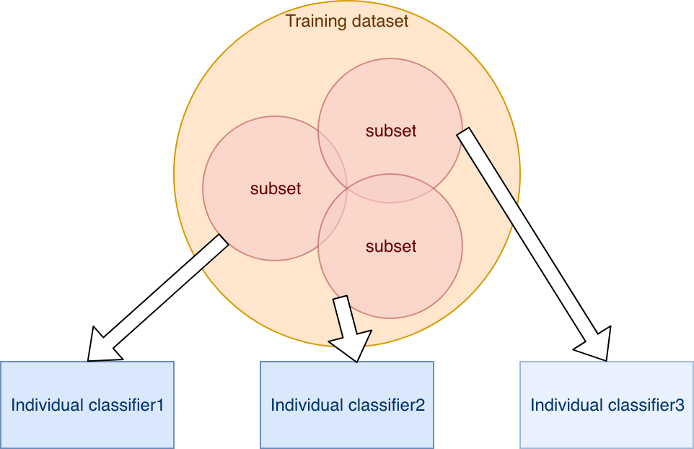

The prediction from individual classifiers are aggregated at the end by majority vote.

A picture containing object, text


Note that random forest is a special case of bagging.

Adaptive Boost

The other ensemble method supported by the is Adaptive Boost, which is also called AdaBoost. AdaBoost is designed to boost performance of weak learners. A weak learner refers to a very simple base classifier that can barely over-perform the Dummy Classifier, which uses random guessing essentially.

Being adaptive means that the individual classifiers are trained and tested one by one, instead of all at the same time. The training of a latter one can then learn from the former ones. Here is how it works.

The first individual classifier is trained by using the whole training dataset as shown in the following graph.

A picture containing sky, text, map, indoor


Then all the mis-classified samples in the training dataset are identified. In the above example,, there is one blue dot being mis-classified. Then the weight for these samples are increased, and then the whole training dataset with updated weight is fed to the next classifier.

A picture containing sky, text, indoor, map


Here we use a bigger dot to represent the increased weight for the blue dot missed by the first classifier. As we shown in the discussion of class_weight section above, this can force the algorithm to pay more attention to fitting these samples with higher weight properly. In other words, these samples that were considered as errors before will less likely show up as errors this time. For the second individual classifier, the decision boundary represented by the orange is thus different from the one of the first individual classifier. The second individual classifier mis-classifies some samples. Then the weight of those samples are increased before being fed to the third individual classifier. This process is repeated for all the remining classifiers. Note that even though the latter ones are improvements of the former ones, all the classifiers are kept. The prediction of the ensemble model uses all classifier.

To predict, the input data is fed into each classifier trained above, and the predictions from them are aggregated by majority vote.